**CHAPTER IV**

**PATIENT INFORMATION SYSTEM FOR ST. LOUISE DE MARILLAC**

*System Overview*

The Patient Information System for St. Louise de Marillac is an offline tool that is developed to make the management of St. Louise de Marillac data easier and more efficient. The system also automates the patients of the St. Louise de Marillac in helping the Medical Personnel improve the workflow and managing records including the past records of patients and the payment transactions records. It intends to follow the performance of the St. Louise de Marillac and sought to explore their perceptions towards competencies.

The Patient Information System for St. Louise de Marillac provides a means for the Medical Personnel to fasten all transactions including payment and allow the Medical Personnel take part by using the system through different features it has to offer. Patients are those who were unable stored their data from their past check-up or transaction with the doctors or medical personnel can utilize the management system application and store their necessary data for checking up their health and other transactions, and update their information regarding their current health diagnose. Through this, each patient may gather, communicate and even organize their own events with the doctors or medical personnel of St. Louise de Marillac who will act as the Doctor and Medical Staff who will help them diagnose their health issues or illness. This is possible through the add patient, schedule, consultation and payment transaction module.

Beneficial to the St. Louise de Marillac and the Medical Personnel in general, the system becomes the extension of communication to be able to update and keep the Medical Personnel informed of all the information that Medical Personnel has to review or analyze every time when the patient comes back for consulting. The patients and patient profile module of the system offers a range of information of the patients and their records which are diagnosis, symptoms, prescriptions and payment transactions that each member would be able to get upon access of the system.

Moreover, the Patient Information System for St. Louise de Marillac is able to generate the needed reports that the Medical Personnel needs to generate for patients preview purposes or other purposes, depending on the specific limits requested by the user of the system.

*The System*

The Patient Information System for St. Louise de Marillac, the result of this study will contribute to the development of the managing of patient records of this clinic. As they continue to adapt and explore the significant feedbacks coming from their patients, they will eventually make some choices and decisions with regards to their future management for their patients.

For the Administrator or Owner, any findings of this study will guide the St. Louise de Marillac to meet and achieve the competitiveness through continuous evaluation and review of their workflow and tasks to serve their patients. They will be able to preview the records of their patients whether the diagnosis, symptoms and prescriptions including the payment transactions are managed and or in need to be further developed.

For the Medical Personnel, this study will help develop a close relationship between patients. Reconnections through getting together can create opportunity to growth and broaden perspectives in different areas of managements and professions.

To the Patients, the study will eventually provide an avenue to create a network of patients being pooled together for a purpose such as consulting. In this case, sharing of resources, knowledges and experiences in any specialist and medical staff can create an opportunity for patients in terms of diagnosing, consulting and managing transactions.

*Login*

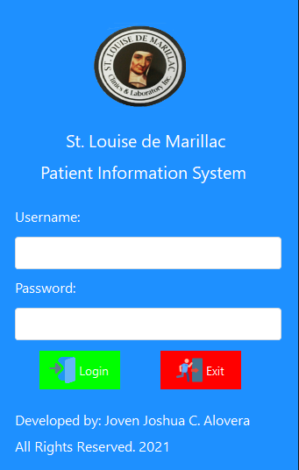

**Figure 5. Login Form**

The login form is where all user login their account to access the security of the system and to access the system. User without account will cannot be access the system. The administrator is only user that can create and update the account of all user.

*Dashboard*

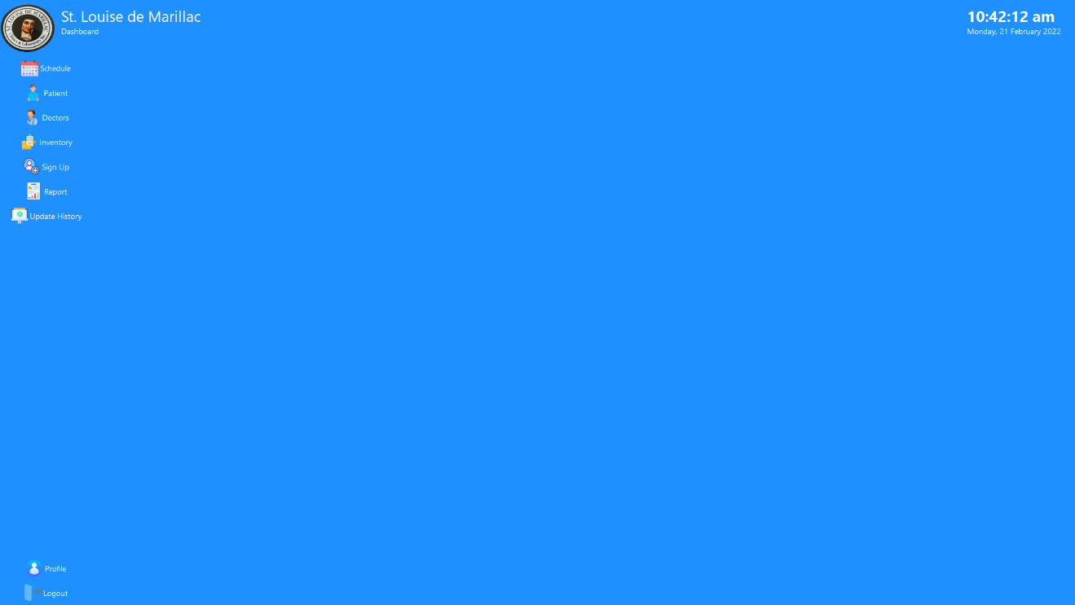

**Figure 6. Dashboard Form for Administrator**

This dashboard form is for administrator, he or she can access everything in the system as you can see at the left side of the dashboard, there are multiple buttons that he or she can click and access, unlike doctor and medical staff will have a limit button and or forms to access which will shown at the figure 7 and figure 8.



**Figure 7. Dashboard Form for Doctor**

This dashboard is for doctor, as you can see it is different from administrator dashboard form. Doctor can only access few forms in the system while administrator can access everything and multiple in the system. This is also the dashboard of the medical staff which will be shown in figure 8. Also, there are features for doctor can access and cannot be access by the medical staff.



**Figure 8. Dashboard Form for Medical Staff**

This dashboard is same as doctor and different from administrator dashboard. However, just like mentioned in figure 7 that there are features for medical staff can access and cannot be access by the doctor, this feature will be shown in further next figure.

*Schedule*

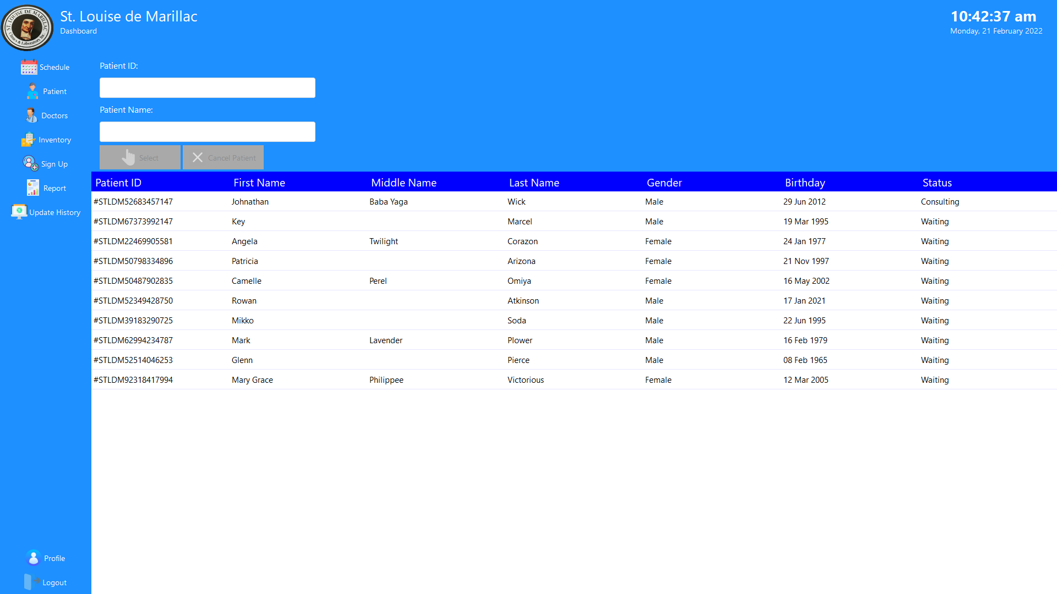

**Figure 9. Schedule Form for Administrator**

As mentioned in previous page that the administrator can access everything in the system. This is the interface schedule form for administrator, he or she can view all the patients who are waiting for their appointments to doctor. Administrator can also select and cancel patient from schedule.

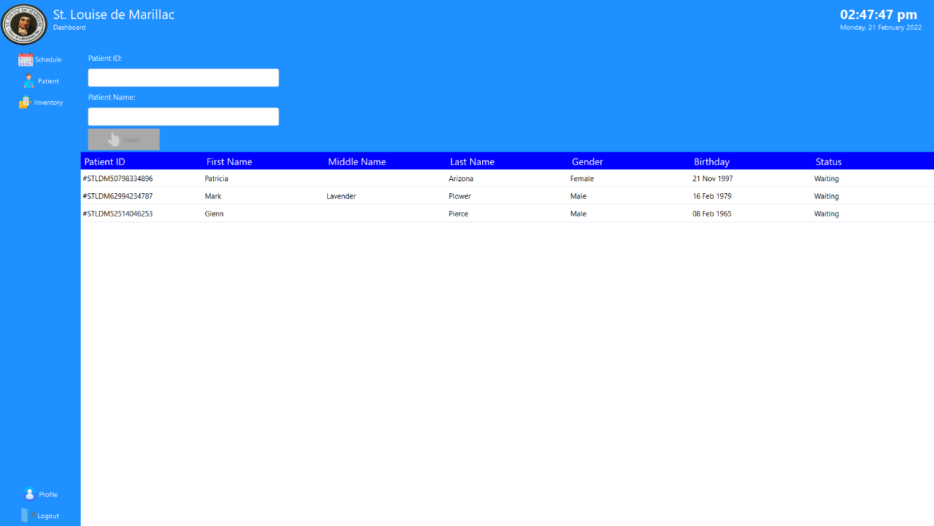

**Figure 10. Schedule Form for Doctor**

This schedule form is for doctor, as you can see the doctor can only have a select button in the schedule form which means doctor can only select the patient for consultation. Doctor cannot cancel the appointments of their patients who are waiting to consult to them.

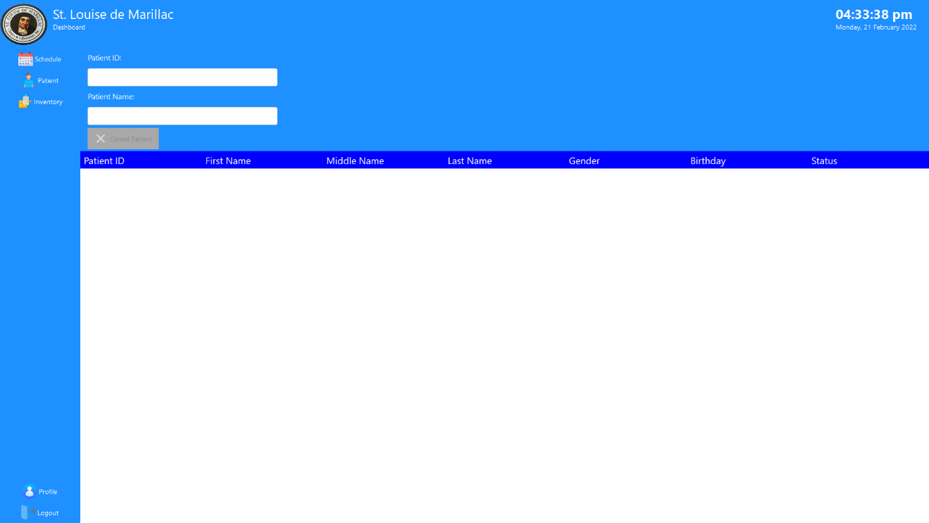

**Figure 11. Schedule Form for Medical Staff**

This schedule form is medical staff, as you can see the medical staff can only have one button that is cancel patient, the role of the medical staff in schedule form is to cancel the patient who are waiting for their appointment with their doctor. If patient has an urgent plan or something that he or she wants to cancel his or her appointment with the doctor, the patient can simply interact with the medical staff to cancel their appointment and medical staff can cancel it in a simple way. The medical staff can also view all the patients who are waiting just like administrator view in figure 9.

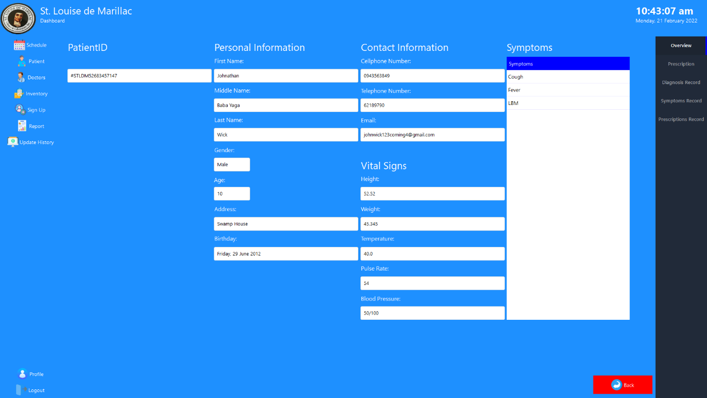

**Figure 12. Consultation Form**

This consultation form can only access by the doctor and administrator, this is the overview information of the patient. At the right side there are sub menu that doctor and administrator can access to store and create diagnosis and prescription for the patient and can view all past records of patient’s diagnosis, symptoms and prescriptions.

